# Row Level Security (RLS)

If you wish to show only certain data to certain groups of users it is possible to do this via **Row Level Security (RLS)**

This is achieved by setting up **Roles** that we can **assign certain users** to.

For example, if we the same report to show only for say ***EU Team*** and ***NON-EU Team*** users we can do this by adding **Roles**

**Adding a Role**

Go to: Modelling > Mange Roles

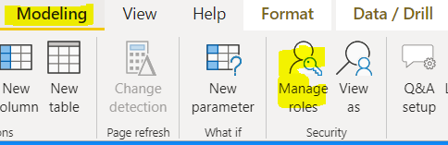

Then add a role e.g. ***EU Team***

**EU Team**

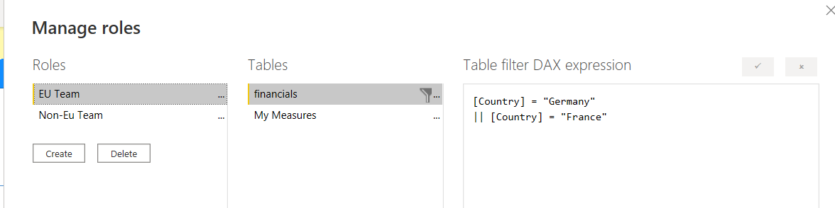

Here we can use DAX Table Filter expressions to ‘filter’ what this user Role can see.

Here we have set the ***EU Team*** Role to only see Countries “Germany” or “France”

[Country] = "Germany"

|| [Country] = "France"

For the ***Non-EU Team***

[Country] <> "Germany" && [Country] <> "France"

**Note: These filters apply to the WHOLE REPORT**

**Testing a Role**

To then test if a Role is working as expected.

Go to: Modelling > View as roles

Test each role as shown below.

It is also possible (once a role is assigned, to test individual user log ins)

Eu Team

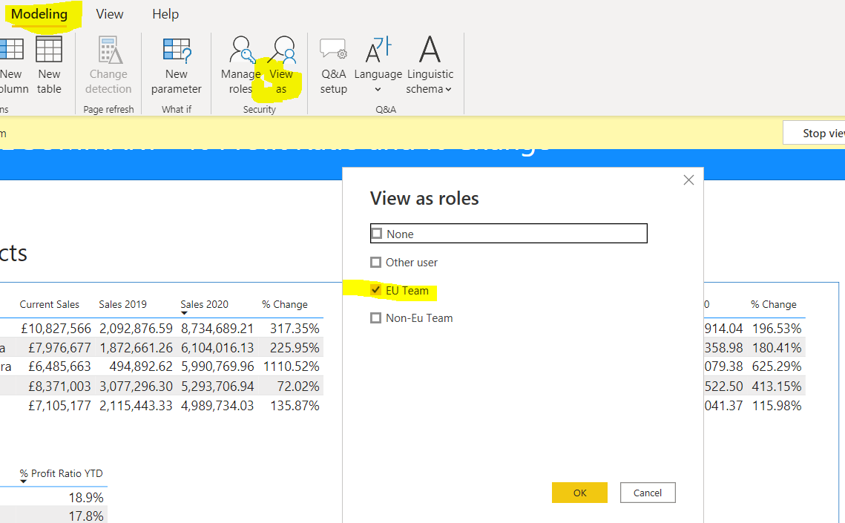

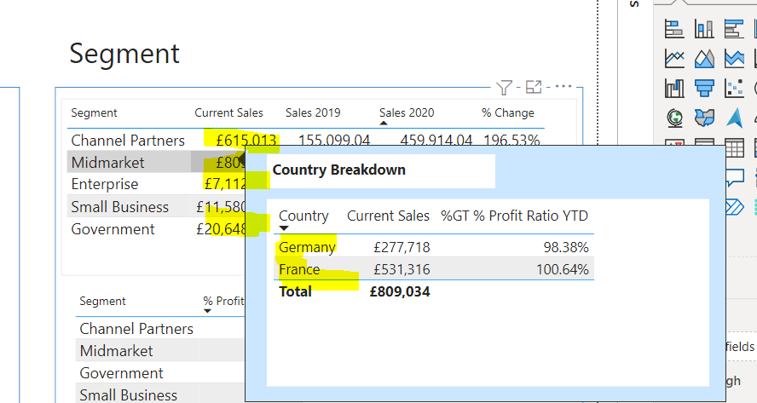

Non-EU Team

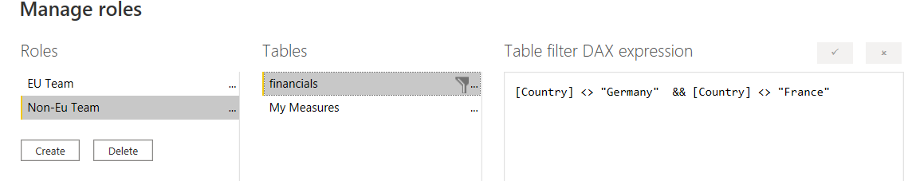

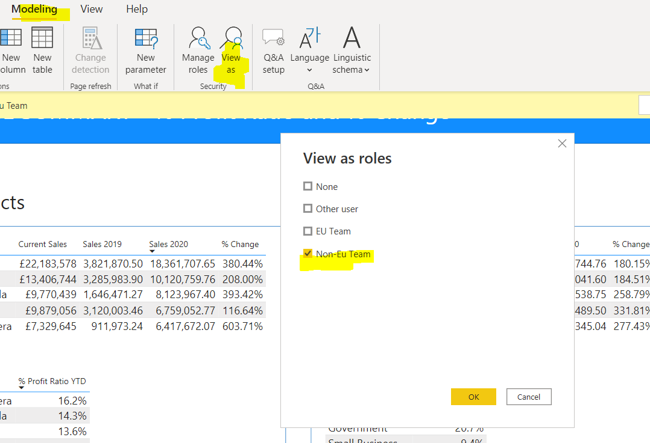

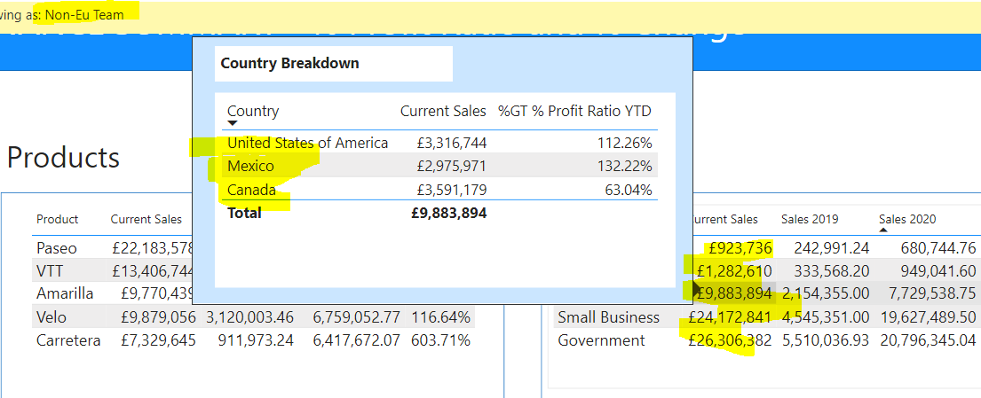

**Setting User Roles**

To assign user roles …..